**Dr. Martin Luther King, Jr.**

**2021 Human Rights Week Lecture**

**“Living the Dream: Perspective, Privilege and Personal Power”**

Presented by

**Representative Ras Smith**

**Iowa House District 62**

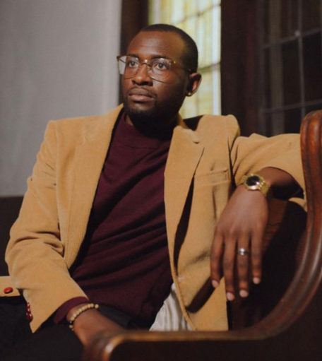

The University of Iowa College of Law

January 29, 2021, 12:40 p.m.

Zoom Link: <HTTPS://UIOWA.ZOOM.US/J/99114585318>

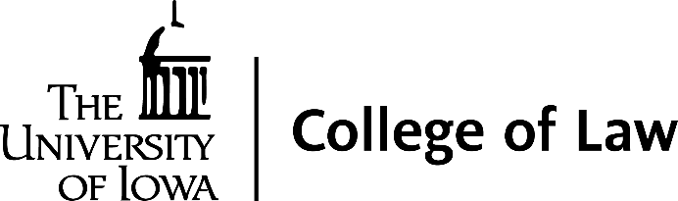

**Dr. Martin Luther King, Jr.**

**2021 Human Rights Week Lecture**

**Program**

**Introduction......... Kevin Washburn**

N. William Hines Dean and Professor of Law

**Brief Remarks….. Professor Christina Bohannan**

Chair, Diversity, Equity, and Inclusion Committee

**Lecture......... Representative Ras Smith**

**Iowa House District 62**

**Title:**

**“Living the Dream: Perspective,**

**Privilege and Personal Power”**

**Questions & Answers: Professor Adrien K. Wing**

**Representative Ras Smith**

**Iowa House District 62**

Representative Ras Smith represents Iowa House District 62, which includes Waterloo, Elk Run Heights, Evansdale, and Raymond. Smith, a Waterloo native, is the son of L.C. and the Rev. Dr. Belinda Creighton-Smith.

Smith graduated from the University of Northern Iowa with a Bachelor's degree in Exercise Science and a Master’s degree in Youth and Human Services.   Smith lives in Waterloo with wife Amelia and their two daughters, Maria and Samara.  Locally, Smith serves on the Executive Advisory Committee for the University of Northern Iowa, and is an Executive Board member of the Urban Agriculture Institute, and the YMCA of Black Hawk County.

Elected to the Iowa House in 2017, Smith currently serves as the Ranking member for the House Education Committee as well as the Chairman of the Iowa Legislative Black Caucus.  Since his time in the legislature, Smith has been an advocate for workers’ rights, social justice, and education reform. He has passed legislation to address police brutality, decrease barriers to small business opportunities, in addition to creating alternative pathways for high school completion.

Since entering the legislature, Smith has been: a recipient of the Cedar Valley 20 under 40 award (2017); a fellow of the Bowhay Institute for Legislative Leadership (2018); the Iowa Democratic Party Hall of Fame Inductee: Rising Star Award (2019); the University of Northern Iowa- United Faculty Legislator of the Year (2019); the Iowa Democratic Party Hall of Fame: We the People Award (2019); and the Progress Iowa: Harkin Heroes Award (2020).

Out of session, Smith is the owner of Rise Advocacy Services which specializes in political consulting as well as grant writing, community engagement and resources development for organizations within the Cedar Valley area and across the state.

**Sponsored by:**

University of Iowa College of Law

**Cosponsored by:**

UI Center for Human Rights

Diversity, Equity, and Inclusion Committee

Black Law Students Association